ASSIGNMENT-1

TEMPERATURE CONTROLLED HOME AUTOMATION(BULB)

TEAM ID: PNT2022TMID21391

TEAM MEMBERS:NISHA C(19D058)

HARNI V(19D028)

FATHIMA D(19D022)

SANGEETHA M(19D134)

COMPONENTS USED:

* Arduino UNO
* Relay Module(5V)
* 16\*2 LCD display
* TMP36 Temperature Sensor
* Light Bulb
* Connecting wires

SCHEMATIC DIAGRAM:

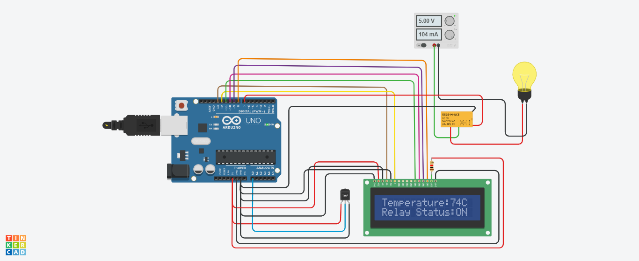

CODE:

#include <LiquidCrystal.h>

LiquidCrystal lcd(13, 12, 11, 10, 9, 8);

int tempin = A0; //output pin of TMP36 temp sensor

int temp;

int celsius;

int tempmin = 69.632;

int relay = 7;

void setup() {

pinMode(tempin, INPUT);

Serial.begin(9600);

lcd.begin(16, 2);

pinMode(relay, OUTPUT);

}

void loop() {

temp = analogRead(tempin);

celsius = temp \* 0.48828125;

Serial.print(celsius);

Serial.println();

if (tempmin < temp) {

lcd.setCursor(0, 1);// move cursor to next line

lcd.print("Relay Status:");

lcd.print("ON"); // displaying temperature and bulb status

digitalWrite(relay, LOW);

}

else {

lcd.setCursor(0, 1);// move cursor to next line

lcd.print("Relay Status:");

lcd.print("OFF"); // displaying temperature and bulb status

digitalWrite(relay, HIGH);

}

lcd.setCursor(0, 0);

lcd.print("Temperature:");

lcd.print(celsius); // displaying temperature

lcd.print("C ");

delay(3000);

lcd.clear();

}

OUTPUT IN SERIAL MONITOR:

